Project Design Phase-II Data Flow Diagram

|  |  |
| --- | --- |
| Date | 22 October 2022 |
| Team ID | PNT2022TMID19657 |
| Project Name | Smart Waste Management System for Metropolitan Cities |
| Maximum Marks | 4 Marks |

# Data Flow Diagrams:

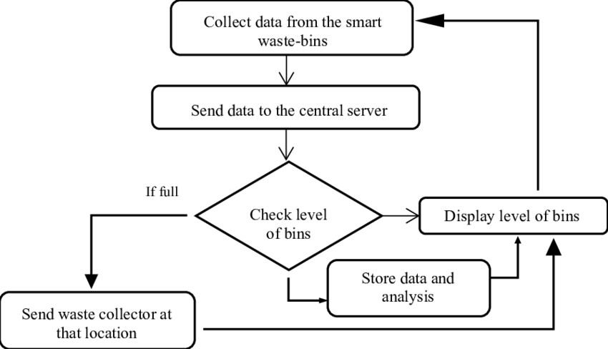

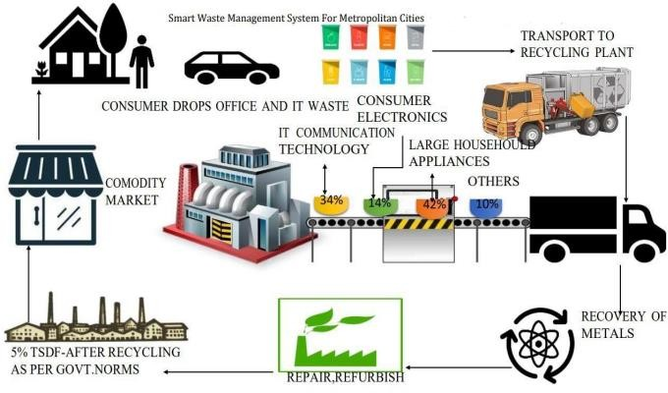

The classic visual representation of how information moves through a system is a data flow diagram (DFD). A tidy and understandable DFD can graphically represent the appropriate quantity of the system demand. It demonstrates how information enters and exits the system, what modifies the data, and where information is kept.

# User Stories:

Use the below template to list all the user stories for the product.

|  |  |  |  |  |  |  |
| --- | --- | --- | --- | --- | --- | --- |
| **User Type** | **Functional Requirement (Epic)** | **User Story Number** | **User Story / Task** | **Acceptance criteria** | **Priority** | **Release** |
| Admin (who manage web server) | Web server login | USN-1 | As a admin, I have my user name and password for every worker and co- workers to manage them | I can manage web account and direct workers | High | Sprint-1 |
| Co-admin | Login | USN-2 | As a co-admin, I'll oversee additional monitoring tasks such garbage level monitoring, location accuracy, garbage sorting, and the timely collection of waste. | I can monitor garbage bins activities. | High | Sprint-2 |
| Customer(Web user) | User | USN-3 | Here comes the client; to observe bin progress and report any issues, he or she will have access to mobile apps or login web pages. | He/she has the right to make a query if any. | High | Sprint-3 |
| Customer Care Executive | Worker | USN-4 | The customer service representative will attempt to resolve client inquiries by getting in touch with co-admin. Inquiries about serious or urgent situations should be directed to higher authorities. | I can attend calls, and respond people, by rectifying the problem. | High | Sprint-4 |
| Truck driver | Worker | USN-5 | Here, a truck driver is a person who has certain responsibilities and who must report when and where, in accordance with the daily plan, the rubbish has been picked up. And ought should  current events on the specified website (webpagelogin) | I can update my activities onsite when the given task has been completed. | Moderate | Sprint-5 |